EXP NO: 11
AIM:
To create an Auto Increment sequence on the Worker relation of the COMPANY database.
DESCRIPTION / PROCEDURE:
1) Create the Worker table with WorkerID as AUTO_INCREMENT PRIMARY KEY.
2) Insert records without specifying WorkerID; MySQL assigns values automatically.
3) Insert a record by manually specifying WorkerID.
4) Drop the AUTO_INCREMENT property using ALTER TABLE.
QUERY:
CREATE TABLE Worker (
WorkerID INT AUTO_INCREMENT PRIMARY KEY,
Name VARCHAR(50),
Department VARCHAR(30),
Salary DECIMAL(10,2),
Phone VARCHAR(15),
DeptManager VARCHAR(50));

INSERT INTO Worker (Name, Department, Salary, Phone, DeptManager) VALUES
('V.Yuvan','IT',20000,'8838997561','Shankar'),
('Fahad','HR',100000,'9996666123','Ravi'),
('Fahim','IT',20000,'1234578123','Ravi');

SELECT * FROM Worker;

INSERT INTO Worker (WorkerID, Name, Department, Salary, Phone, DeptManager)
VALUES (1055,'Hariharan','IT',50000,'9814521123','Ravi');

ALTER TABLE Worker MODIFY WorkerID INT NOT NULL;

OUTPUT:
WorkerID | Name | Department | Salary | Phone | DeptManager
1 | V.Yuvan | IT | 20000 | 8838997561 | Shankar
2 | Fahad | HR | 100000 | 9996666123 | Ravi
3 | Fahim | IT | 20000 | 1234578123 | Ravi
1055 | Hariharan | IT | 50000 | 9814521123 | Ravi

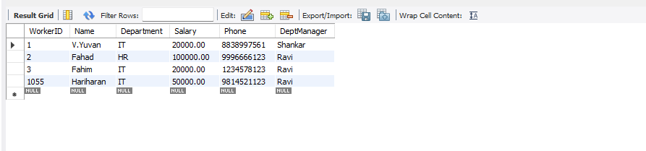

RESULT:
Thus the AUTO_INCREMENT sequence was created and verified on the Worker table successfully.

SIMPLE PROGRAMMING USING REPEAT, WHILE
EXP NO: 12
AIM:
To write MySQL programs using WHILE and REPEAT loop statements on the Worker table.
DESCRIPTION / PROCEDURE:
1) Declare a counter and a string variable.
2) In program 1, use WHILE to append department names until counter x exceeds 5.
3) In program 2, use REPEAT to keep adding 5000 to a worker's salary until it reaches 150000.
4) Display the final result using SELECT.
QUERY:
-- Program 1: WHILE
DELIMITER $$
CREATE PROCEDURE GenerateDeptList()
BEGIN
DECLARE x INT DEFAULT 1;
DECLARE dept_list VARCHAR(200) DEFAULT '';
WHILE x <= 5 DO
CASE x
WHEN 1 THEN SET dept_list = CONCAT(dept_list,'IT, ');
WHEN 2 THEN SET dept_list = CONCAT(dept_list,'HR, ');
WHEN 3 THEN SET dept_list = CONCAT(dept_list,'Software Developer, ');
WHEN 4 THEN SET dept_list = CONCAT(dept_list,'Software Engineering, ');
WHEN 5 THEN SET dept_list = CONCAT(dept_list,'Admin');
END CASE;
SET x = x + 1;
END WHILE;
SELECT dept_list AS DepartmentList;
END$$
DELIMITER ;
CALL GenerateDeptList();

-- Program 2: REPEAT
DELIMITER $$
CREATE PROCEDURE IncrementSalary(IN p_salary DECIMAL(10,2), OUT p_final DECIMAL(10,2))
BEGIN
REPEAT
SET p_salary = p_salary + 5000;
UNTIL p_salary >= 150000
END REPEAT;
SET p_final = p_salary;
END$$
DELIMITER ;
CALL IncrementSalary(20000, @final);
SELECT @final AS FinalSalary;

OUTPUT:
DepartmentList: IT, HR, Software Developer, Software Engineering, Admin
FinalSalary: 150000

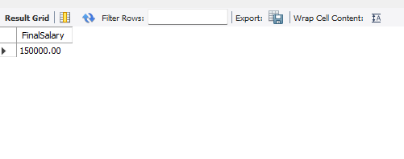

RESULT:
Thus the programs using WHILE and REPEAT loop statements were executed successfully.

SIMPLE PROGRAMMING USING CASE AND LOOP
EXP NO: 13
AIM:
To write MySQL programs using CASE statement and LOOP construct on the Worker table.
DESCRIPTION / PROCEDURE:
1) In program 1, use CASE to classify each worker's income level based on Salary.
2) In program 2, use LOOP with ITERATE and LEAVE to raise a worker's salary by 10000 repeatedly until it reaches 150000.
QUERY:
-- Program 1: CASE
DELIMITER $$
CREATE FUNCTION SalaryLevel(p_salary DECIMAL(10,2)) RETURNS VARCHAR(20)
DETERMINISTIC
BEGIN
DECLARE income_level VARCHAR(20);
CASE
WHEN p_salary <= 50000 THEN SET income_level = 'Low Income';
WHEN p_salary <= 120000 THEN SET income_level = 'Medium Income';
ELSE SET income_level = 'High Income';
END CASE;
RETURN income_level;
END$$
DELIMITER ;
SELECT Name, Salary, SalaryLevel(Salary) AS IncomeLevel FROM Worker;

-- Program 2: LOOP
DELIMITER $$
CREATE PROCEDURE RaiseSalary(IN p_salary DECIMAL(10,2), OUT p_final DECIMAL(10,2))
BEGIN
DECLARE v_salary DECIMAL(10,2) DEFAULT p_salary;
raise_loop: LOOP
IF v_salary >= 150000 THEN
LEAVE raise_loop;
END IF;
SET v_salary = v_salary + 10000;
ITERATE raise_loop;
END LOOP raise_loop;
SET p_final = v_salary;
END$$
DELIMITER ;
CALL RaiseSalary(20000, @f);
SELECT @f AS FinalSalary;

OUTPUT:
Name | Salary | IncomeLevel
V.Yuvan | 20000 | Low Income
Fahad | 100000 | Medium Income
Shankar | 200000 | High Income



RESULT:
Thus the programs using CASE and LOOP were executed successfully.

TCL COMMANDS - COMMIT, SAVEPOINT, ROLLBACK
EXP NO: 14
AIM:
To perform transaction control on the Worker table using COMMIT, SAVEPOINT and ROLLBACK.
DESCRIPTION / PROCEDURE:
1) Update a worker's salary.
2) Create SAVEPOINT A and insert a new worker.
3) Create SAVEPOINT B and insert another worker.
4) Roll back to SAVEPOINT A to undo both inserts, keeping the salary update.
5) COMMIT the transaction to save it permanently.
QUERY:
UPDATE Worker SET Salary = 130000 WHERE WorkerID = 1865;
SAVEPOINT A;
INSERT INTO Worker VALUES (1900,'Karthik','IT',60000,'9000011122','Ravi');
SAVEPOINT B;
INSERT INTO Worker VALUES (1901,'Priya','HR',70000,'9000022233','Shankar');
SELECT * FROM Worker;
ROLLBACK TO A;
SELECT * FROM Worker;
COMMIT;

OUTPUT:
After ROLLBACK TO A, the two new rows (Karthik, Priya) are removed, but the salary update for WorkerID 1865 is retained and then permanently saved by COMMIT.

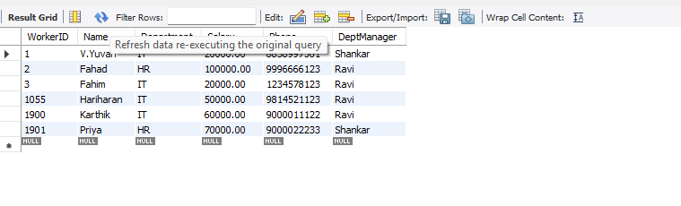
RESULT:
Thus the TCL commands COMMIT, SAVEPOINT and ROLLBACK were executed successfully.

DCL COMMANDS - GRANT, REVOKE
EXP NO: 15
AIM:
To control user privileges on the Worker table using GRANT and REVOKE.
DESCRIPTION / PROCEDURE:
1) Create a new user 'hrclerk'.
2) Grant session creation, SELECT and INSERT privileges on the Worker table.
3) View the granted privileges using SHOW GRANTS.
4) Revoke the INSERT privilege from the user.
QUERY:
CREATE USER 'hrclerk'@'localhost' IDENTIFIED BY 'Hr@1234';
GRANT CREATE SESSION TO 'hrclerk'@'localhost';
GRANT SELECT, INSERT ON company.Worker TO 'hrclerk'@'localhost';
SHOW GRANTS FOR 'hrclerk'@'localhost';
REVOKE INSERT ON company.Worker FROM 'hrclerk'@'localhost';
SHOW GRANTS FOR 'hrclerk'@'localhost';

OUTPUT:
Before REVOKE: hrclerk has CREATE SESSION, SELECT, INSERT on Worker.

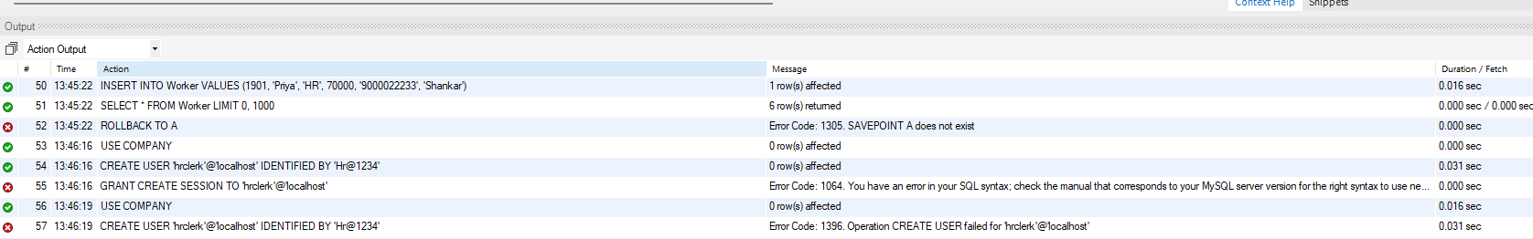

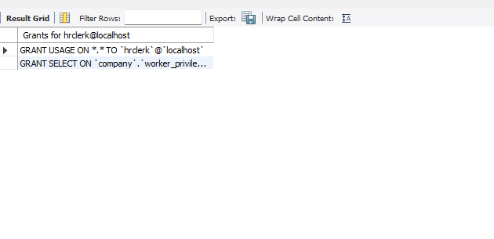
RESULT:
Thus the DCL commands GRANT and REVOKE were executed successfully.

HIGH LEVEL PROGRAMMING EXTENSIONS - PROCEDURES
EXP NO: 16
AIM:
To implement stored procedures on the Worker table.
DESCRIPTION / PROCEDURE:
1) Create a simple procedure to fetch all records from Worker.
2) Create a procedure GetWorkerLevel() that accepts a WorkerID and returns PLATINUM/GOLD/SILVER based on Salary.
3) Call both procedures and display the result.
QUERY:
DELIMITER $$
CREATE PROCEDURE GetAllWorkers()
BEGIN
SELECT * FROM Worker;
END$$
DELIMITER ;
CALL GetAllWorkers();

DELIMITER $$
CREATE PROCEDURE GetWorkerLevel(IN p_workerid INT, OUT p_level VARCHAR(20))
BEGIN
DECLARE v_salary DECIMAL(10,2);
SELECT Salary INTO v_salary FROM Worker WHERE WorkerID = p_workerid;
IF v_salary > 150000 THEN
SET p_level = 'PLATINUM';
ELSEIF v_salary >= 80000 THEN
SET p_level = 'GOLD';
ELSE
SET p_level = 'SILVER';
END IF;
END$$
DELIMITER ;
CALL GetWorkerLevel(1501, @level);
SELECT @level AS WorkerLevel;

OUTPUT:
WorkerLevel for WorkerID 1501 (Shankar, Salary 200000) = PLATINUM


RESULT:
Thus the procedures were created and executed successfully.

HIGH LEVEL PROGRAMMING EXTENSIONS - FUNCTIONS
EXP NO: 17
AIM:
To implement a function and a recursive procedure using MySQL.
DESCRIPTION / PROCEDURE:
1) Create a function WorkerCategory() that returns PLATINUM/GOLD/SILVER based on Salary.
2) Set the recursion depth and create a recursive procedure Factorial().
3) Call both and display the results.
QUERY:
DELIMITER $$
CREATE FUNCTION WorkerCategory(p_salary DECIMAL(10,2)) RETURNS VARCHAR(20)
DETERMINISTIC
BEGIN
IF p_salary > 150000 THEN RETURN 'PLATINUM';
ELSEIF p_salary >= 80000 THEN RETURN 'GOLD';
ELSE RETURN 'SILVER';
END IF;
END$$
DELIMITER ;
SELECT Name, Salary, WorkerCategory(Salary) AS Category FROM Worker;

SET @@session.max_sp_recursion_depth = 255;
DELIMITER $$
CREATE PROCEDURE Factorial(IN n INT, OUT result BIGINT)
BEGIN
DECLARE temp BIGINT;
IF n <= 1 THEN SET result = 1;
ELSE
CALL Factorial(n-1, temp);
SET result = n * temp;
END IF;
END$$
DELIMITER ;
CALL Factorial(5, @f);
SELECT @f AS FactorialResult;

OUTPUT:
FactorialResult = 120 (for n = 5)

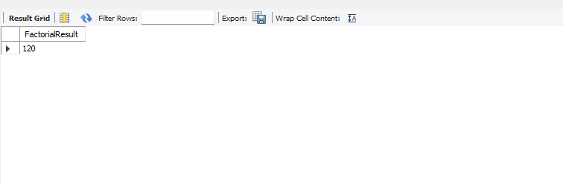
RESULT:
Thus the function and the recursive procedure were executed successfully.

HIGH LEVEL LANGUAGE EXTENSION WITH CURSORS
EXP NO: 18
AIM:
To implement a cursor program on the Worker table.
DESCRIPTION / PROCEDURE:
1) Declare an explicit cursor for the Phone column of Worker.
2) Open the cursor and fetch rows one by one in a loop.
3) Concatenate each phone number into a single string.
4) Close the cursor and display the final list.
QUERY:
DELIMITER $$
CREATE PROCEDURE build_phone_list(INOUT phone_list VARCHAR(4000))
BEGIN
DECLARE v_finished INT DEFAULT 0;
DECLARE v_phone VARCHAR(15) DEFAULT '';
DECLARE phone_cursor CURSOR FOR SELECT Phone FROM Worker;
DECLARE CONTINUE HANDLER FOR NOT FOUND SET v_finished = 1;
OPEN phone_cursor;
get_phone: LOOP
FETCH phone_cursor INTO v_phone;
IF v_finished = 1 THEN LEAVE get_phone; END IF;
SET phone_list = CONCAT(v_phone,';',phone_list);
END LOOP get_phone;
CLOSE phone_cursor;
END$$
DELIMITER ;
SET @phone_list = '';
CALL build_phone_list(@phone_list);
SELECT @phone_list AS PhoneList;

OUTPUT:
PhoneList: all worker phone numbers concatenated, separated by semicolons.

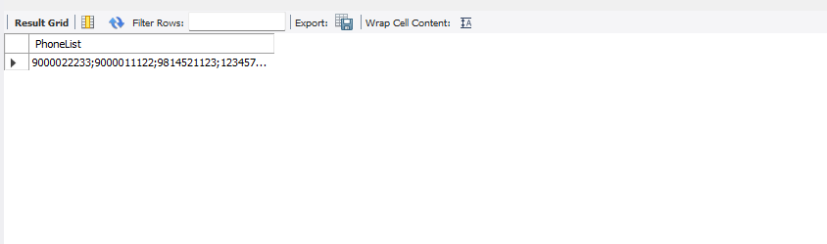
RESULT:
Thus the cursor program was executed successfully on the Worker table.

IMPLEMENTATION OF TRIGGER
EXP NO: 19
AIM:
To implement a BEFORE UPDATE trigger on the Worker table.
DESCRIPTION / PROCEDURE:
1) Create a Worker_Audit table to log salary changes.
2) Create a BEFORE UPDATE trigger that inserts old and new salary values into Worker_Audit.
3) Update a worker's salary to fire the trigger.
4) Check the Worker_Audit table.
QUERY:
CREATE TABLE Worker_Audit (
AuditID INT AUTO_INCREMENT PRIMARY KEY,
WorkerID INT,
OldSalary DECIMAL(10,2),
NewSalary DECIMAL(10,2),
ChangedOn DATETIME);

DELIMITER $$
CREATE TRIGGER before_worker_update
BEFORE UPDATE ON Worker
FOR EACH ROW
BEGIN
INSERT INTO Worker_Audit(WorkerID, OldSalary, NewSalary, ChangedOn)
VALUES (OLD.WorkerID, OLD.Salary, NEW.Salary, NOW());
END$$
DELIMITER ;

UPDATE Worker SET Salary = 135000 WHERE WorkerID = 1865;
SELECT * FROM Worker_Audit;

OUTPUT:
Worker_Audit shows WorkerID 1865, OldSalary 120000, NewSalary 135000, with timestamp.

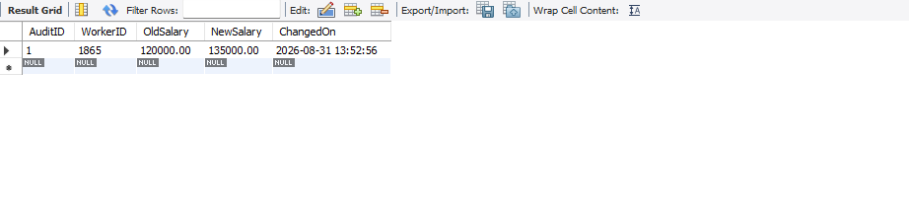
RESULT:
Thus the trigger was created and executed successfully.

MYSQL STRING FUNCTIONS - REPLACE, REPEAT, REVERSE, RIGHT, LEFT, RPAD, LPAD
EXP NO: 20
AIM:
To implement REPLACE, REPEAT, REVERSE, RIGHT, LEFT, RPAD and LPAD string functions on the Worker table.
DESCRIPTION / PROCEDURE:
1) Use REPLACE() to shorten the Department name.
2) Use REPEAT() to print a repeated character string.
3) Use REVERSE() to reverse each worker's name.
4) Use RIGHT() to show the last 4 digits of Phone.
5) Use LEFT() to show the first 3 letters of Name.
6) Use RPAD() and LPAD() to pad Name and WorkerID.
QUERY:
SELECT Name, REPLACE(Department,'Software','Sw') AS ShortDept FROM Worker;
SELECT REPEAT('*',5) AS Stars;
SELECT Name, REVERSE(Name) AS ReversedName FROM Worker;
SELECT Name, RIGHT(Phone,4) AS Last4Digits FROM Worker;
SELECT Name, LEFT(Name,3) AS ShortName FROM Worker;
SELECT RPAD(Name,15,'.') AS PaddedName FROM Worker;
SELECT LPAD(WorkerID,6,'0') AS FormattedID FROM Worker;

OUTPUT:
Name | ShortDept | ReversedName | Last4Digits | FormattedID
V.Yuvan | IT | nauYV. | 7561 | 001101
Santhosh | Sw Developer | hsohtnaS | 4123 | 001405
Dhanush | Sw Engineering | hsunahD | 2941 | 001125

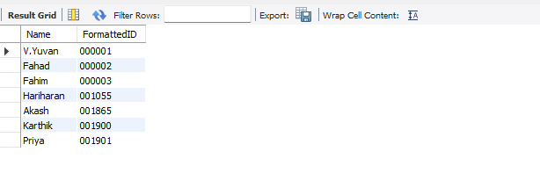

RESULT:
Thus the string functions REPLACE, REPEAT, REVERSE, RIGHT, LEFT, RPAD and LPAD were executed successfully.

